MICROSERVICES WITH SPRING BOOT 3 AND SPRING CLOUD

MANDATORY EXERCISES O/P:
WEEK 4:
EXERCISE 1:
ACCOUNTAPPLICATION SERVER( PORT: 8080):
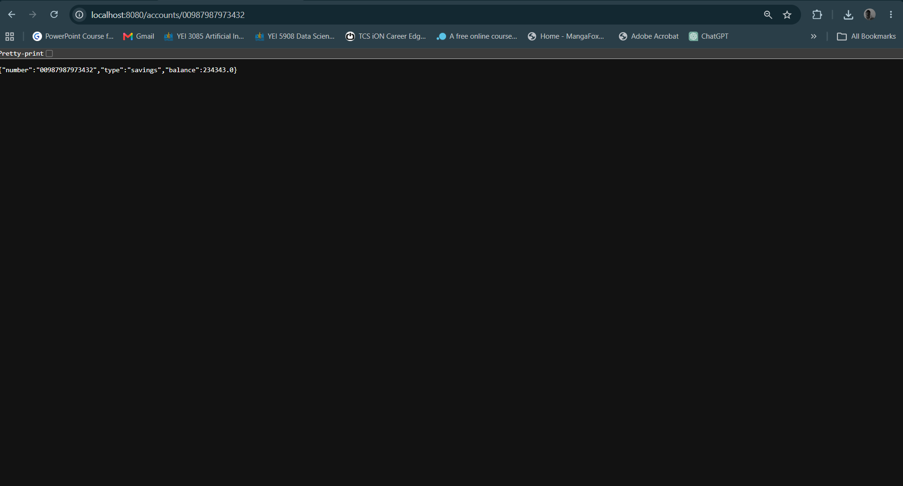
LOANAPPLICATION.JAVA(PORT:8081):
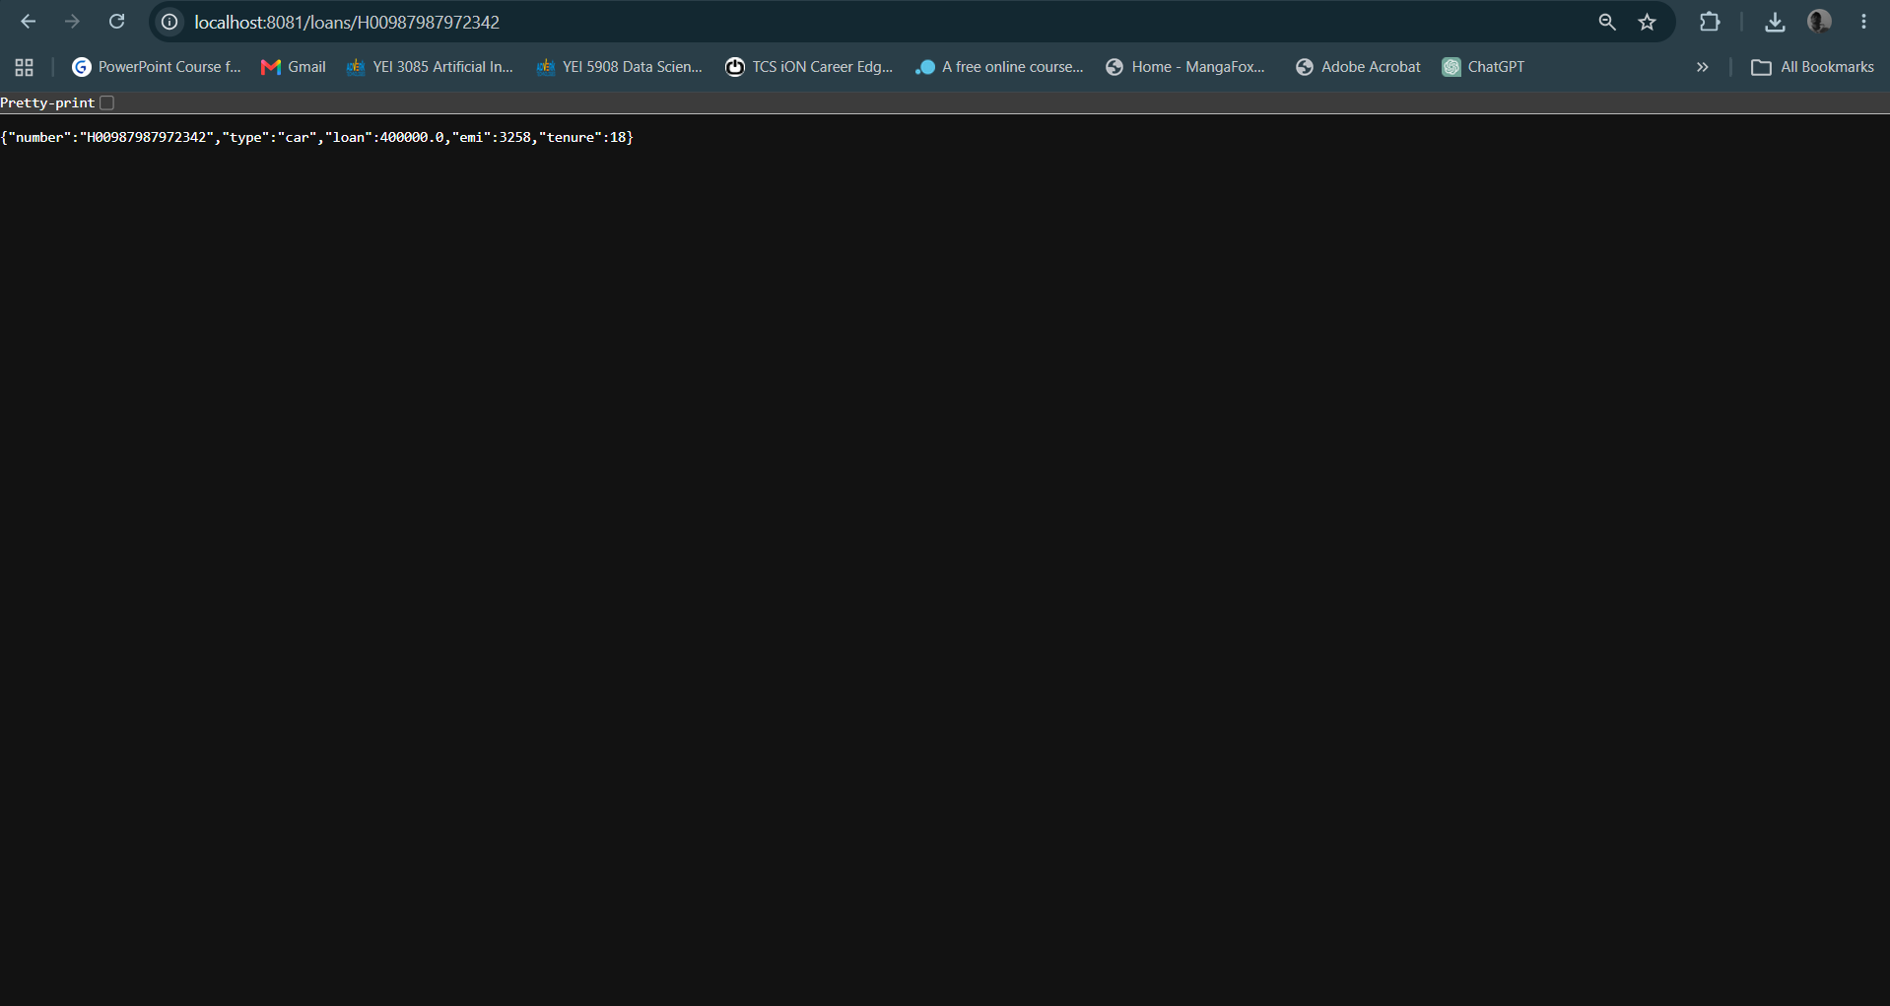

FILE STRUCTURE:

ACCOUNT:
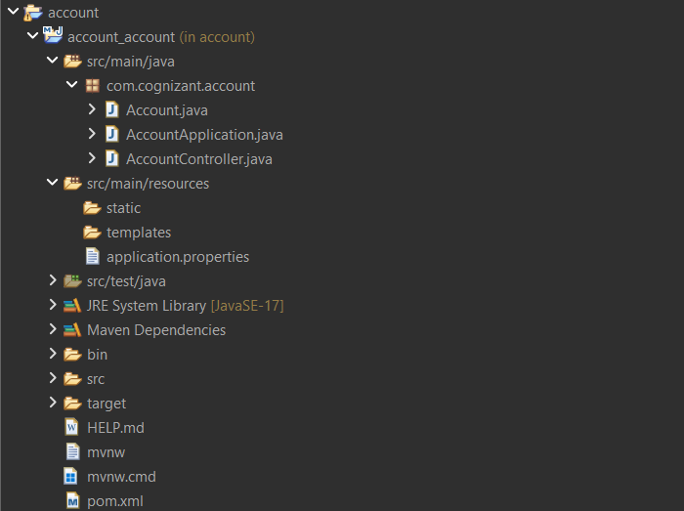
LOAN:
